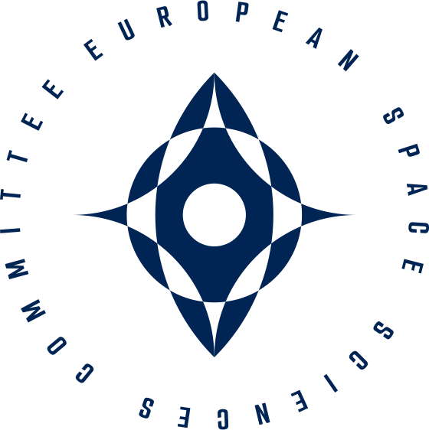

Statement by the European Science Foundation’s European Space Sciences Committee to the CM25 ESA Delegations
Prof. Chris Rapley CBE, MAE - ESSC Chair
Bremen, as delivered 26thNovember 2025
Chair, Ministers, Colleagues,
It is the role of the European Space Sciences Committee to be the ‘voice’ of the European space science community.
In this respect, I draw your attention to the documentation we have provided on the science content of the Director General’s proposal to help you with your decisions. These were submitted digitally at the end of July, and printed copies are available at the back of this hall.

Space is hard.
It is unforgiving.
It is the ultimate test of our technical prowess and collective resolve.
Yet its rewards are transformative:
- a unique vantage point on the Universe, the Solar System, and our home planet
- a laboratory freed from gravity
- a gateway to new resources and economic frontiers
- and a pivotal domain for global power, influence and security
At this time of major geopolitical shifts, the imperative for Europe is clear; we must seize the moment, build upon our robust foundations, and move decisively to secure our continuing scientific excellence, technological sovereignty and self-reliance.
For over 50 years, the European Space Agency’s success has been powered by the critical interplay between technological advance and scientific discovery - the push of innovation and the pull of the unknown - yielding benefits that cascade back to Earth, fuelling prosperity and security.
The CM25 programme proposals for Mandatory activities, Human abd Robotic Exploration, and Earth Observation offer the means to build upon this legacy.
Having served as an ex-officio member of the Space Science, Human Spaceflight and Exploration, and Earth Observation advisory committees for the past six years, I can attest first-hand to the exceptional competence, professionalism, and dedication of the ESA teams – both in general, and in their support for front-ranking science.
Without doubt: ESA delivers.
With this in mind, and in a world of accelerating competition and global challenges in which Europe must secure its place, the European Space Sciences Committee emphatically urges all Delegations to “fully support the science-driven elements of the ESA CM25 programme proposal”.
By investing boldly in science across ESA's programmes, Europe will position itself as a global leader at the frontiers of discovery, a protector of our planet, a pioneer of the new space economy, a partner of choice for joint space ventures, and a beacon of inspiration for generations to come.
The future is not a destination to be reached, but one to be built.
The science community is eager to play its part.
Thank you.

